**SAP UI5 Interview Questions?**

***1)*** ***What is the difference between onInit () and createContent ()***?

**Ans:--**

CreateContent ():

* It is used in the JS view.
* It is called initially once after the controller has been instantiated.
* This method is used to create the UI controls.
* It is not one of the lifecycle hook methods.

OnInit ():

* It is used in the controller.
* It is called when a view is instantiated and its controls (if available) have already been created.
* It is used to modify the view before it is displayed to bind event handlers and do other one-time initialization.
* It is a controller lifecycle hook method.

The main difference is that usually the createContent method is used in the view to create the UI controls that will be rendered on the browser.

But the onInit method does not contain any UI controls and, is used only for one time initialization such as binding and routing.

If you want any control to be displayed, the create content method is mandatory for the JS views. But if you are not initializing or performing at one time global operation,

You can omit the onInit method also.

***2) I could see that Create Content () is called before OnInit (). Why it is like this?***

**Ans:--**

Create content is called whenever the view is instantiated, so that the controls can be rendered. Once the create content is called,

Then only the onInit of the controller will be called.

***3) If you declared a function in component.js file...how you will use in controller?***

**Ans: --** this.getOwnerComponent()

***4) How you will use two oData services/Models in a single Page/view?***

**Ans: --** In Manifest.json file having data sources option. Use that one to create new OData model.

***5) Can I declare two targets for One Route?***

**Ans: --** No, one route for one target only.

***6) Which Control you will use to change the color of the table column like quantity?***

**Ans: --** **Control:** objectNumber **Property:** state

Ex: Error, Information, None, Success, Warning

***7) How you will change the color of the table column data?***

**Ans: --** Through Formatters or Inline Expressions

**Note:** Inline Expressions are also called as **Complex binding** or **Expression Binding**

***8) Logic for inline Functions () to change the color of the table column?***

**Ans: --** numberState = "{=${Model>ExtendedPrice} > 50?’Error’: 'Success'}"

***9) Why you are declaring routes in array of objects?***

**Ans: --** Because the routes are declared in **Manifest.json** file. So that is in json format.

***10) What is function for routing in SAP UI5 and how you will pass data to one view to another view?***

**Ans:--**

var oRouter = sap.ui.core.UIComponent.getRouterFor(this);

oRouter.navTo("view2");

***11) If you want to use same UI elements in so many times in your project then which concept you will use for that?***

**Ans: --** Fragments, it does not have a own Controller.

***12) Fragments does not have a controller then how it will work?***

**Ans: --** Fragments are declared in a view..... It will take it as a view controller.

***13) How to access the two controllers for the same view?***

**Ans: --**One controller with multiple views

One parent view with one parent controller, which act as a container for one or more view-controller pairs.

Regarding the latter, imagine a parent page with a left pane as separate view-controller combo, and a right pane with its own view-controller combo.

Each controller can call one of the other controllers (f.i., **sap.ui.getCore ().byId("nextController").getController();**

var oController = sap.ui.getCore().byId("idView1").getController();

Well I would add upon one more point for regarding the syntax related to access the methods inside the other controller.

**sap.ui.controller("multiplecontroller.Second").methodName();**

***14) How to call Nested Views in SAP UI5?***

**Ans:--**  
**Syntax: -- <mvc:XMLView viewName=”name of your view”/>**

Basically 3 steps required:

1) Create a View and its controller in the specific folders.

2) Instantiate the Nested view in the view, with the above single line of code.

3) Write the desired code in the newly created Nested View.

***15) Explain OData Create, Update, Read, Delete Operations?***

***Ans:--***

***Read: here we will call OData Model in that we have to pass service url, credentials***

*oModel.read (path, null, null, true, function (){});*

serviceurl = "/sap/opu/odata/sap/ZODATA_CUST_DETAILS_SRV";

**var** oModel = **new** sap.ui.model.odata.ODataModel(serviceurl,**true**,"sapuser","India123");

**var** json = **new** sap.ui.model.json.JSONModel();

oModel.read ("/zcust_detailsSet", **null**, **null**, **true**, **function**(data){

json.setData (data);

});

sap.ui.getCore().setModel(json);

***Create:***

*oModel. Create (path, object, null, function ( ){ } );*

*Create operation we have to pass object.*

**var** newData = {

"Customernumber":EMP_No,

"Customername": EMP_Name,

"Phone": EMP_Phone,

"City": EMP_City

}

**var** oModel =**new** sap.ui.model.odata.ODataModel(serviceurl,**true**);

oModel.create('/zcust_detailsSet',newData,**null**, **function**(){

sap.m.MessageToast.show("Successfully Created");

},**function**(){

sap.m.MessageToast.show("Error on Creation!");

});

sap.ui.getCore().setModel(oModel);

***Update:***

*oModel.update(path(key),object,null,function( ){ } );*

*update operation we have to pass object with key.*

**var** newData = {

"Customernumber":EMP_NoE,

"Customername":EMP_NameIDE,

"Phone": EMP_PhoneIDE,

"City": EMP_CityIDE,

}

**var** oModel = **new** sap.ui.model.odata.ODataModel("/sap/opu/odata/sap/ZODATA_CUST_DETAILS_SRV",**true**);

sap.ui.getCore().setModel(oModel);

oModel.update("/zcust_detailsSet('" + EMP_NoE + "')", newData, **null**, **function**(){

sap.m.MessageToast.show("Details Updated Successfully!");},

**function**(){

sap.m.MessageToast.show("Error on Updataing!");

});

***Delete:***

*oModel.remove(path(key),null,function( ){ } );*

*remove operation we have to pass key.*

**var** oModel =**new** sap.ui.model.odata.ODataModel(serviceurl,**true**);

sap.ui.getCore().setModel(oModel);

oModel.remove("/zcust_detailsSet('" + key + "')", **null**, **function**(){

sap.m.MessageToast.show("Delete successful");

},**function**(){

sap.m.MessageToast.show("Delete failed");});

***16) What is AJAX call?***

***Ans: --*** An **Ajax** call is an asynchronous request initiated by the browser that does not directly result in a page transition. A servlet request is a Java-specific term for servicing an HTTP request that could get a simple GET or POST (etc) or an **Ajax** request.

***17) Difference between AJAX Call and OData?***

***Ans: --*** There are various ways by which we can call an Odata web service in our fiori/ui5 application for eg. Using Odata model or by using JQuery Ajax.

***18) What is Component-Preload.js?***

***Ans: -- Performance is always very important. By using a Component-preload.js file in your custom developed Fiori App (“Build your own Fiori App in the cloud”)****startup and runtime performance can be improved****.***

***19) What is Entity?***

***Ans:--***

An entity is an object that is represented in the database. For example Mohit, Vasu, CSE306 etc.

An entity is represented or defined by set of attributes. Attributes are the properties used to describe an entity. For example, a STUDENT entity may have a Name, Roll number, Class, Marks etc. where STUDENT is the entity and name roll number class marks are the attributes.

***20) What is Entity Type?***

***Ans: --*** It is collection of entity having common attribute. As in Student table each row is an entity and have common attributes. So **STUDENT** is an entity type which contains entities having attributes id, name and Age. Also each entity type in a database is described by a name. We may say a table is an **entity type**.

***21) What is Entity Set?***

***Ans: --*** *It is a set of entities of same entity type. So a set of one or more entities of Student Entity type is an Entity Set.*

*For example, in table STUDENT id, name and Age are properties of an entity of entity type student. Hence these are attributes.*

***22) What is Association?***

***Ans:--***

**Association***is a relationship between two objects. In other words, association defines the multiplicity between objects. You may be aware of one-to-one, one-to-many, many-to-one, many-to-many all these words define an association between objects. Aggregation is a special form of* ***association****.*

***23) What is Association Type?***

***Ans:--***

An *association type* (also called an association) is the fundamental building block for describing relationships in the Entity Data Model (EDM). In a conceptual model, an association represents a relationship between two [entity types](https://docs.microsoft.com/en-us/dotnet/framework/data/adonet/entity-type) (such as **Customer** and **Order**). In an application, an instance of an association represents a specific association (such as an association between an instance of **Customer** and an instance of **Order**). Association instances are logically grouped in an [association set](https://docs.microsoft.com/en-us/dotnet/framework/data/adonet/association-set).

***24) What is Association Set?***

***Ans: --*** An *association set* is a logical container for [association](https://docs.microsoft.com/en-us/dotnet/framework/data/adonet/association-type) instances of the same type. An association set is not a data modeling construct; that is, it does not describe the structure of data or relationships. Instead, an association set provides a construct for a hosting or storage environment (such as the common language runtime or a SQL Server database) to group association instances so that they can be mapped to a data store.

An association set is defined within an [entity container](https://docs.microsoft.com/en-us/dotnet/framework/data/adonet/entity-container), which is a logical grouping of [entity sets](https://docs.microsoft.com/en-us/dotnet/framework/data/adonet/entity-set) and association sets.

A definition for an association set contains the following information:

* The association set name. (Required)
* The association of which it will contain instances. (Required)
* Two [association set ends](https://docs.microsoft.com/en-us/dotnet/framework/data/adonet/association-set-end).

***25) Drawback of SAP Fiori?***

***Ans: --*** One of the most commonly cited SAP Fiori disadvantages is a **perceived lack of flexibility**. Because SAP Fiori apps are individually optimized for certain tasks, they may not fit the business logic of a particular organization.

***26) What is DOM?***

***Ans: --*** *The* ***DOM*** *is a W3C (World Wide Web Consortium) standard. The DOM defines a standard for accessing documents: "****The W3C Document Object Model (DOM) is a platform and language-neutral interface that allows programs and scripts to dynamically access and update the content, structure, and style of a document."***

***27) What is MVC architecture?***

***Ans: -- Model–view–controller (MVC)*** *is a software architecture pattern, which separates the representation of information from the user's interaction with it.**The* ***model*** *consists of application data, business rules, logic, and functions.**A* ***view*** *can be any output representation of data, such as a chart or a diagram. Multiple views of the same data are possible, such as a bar chart for management and a tabular view for accountants.* *The* ***controller*** *mediates input, converting it to commands for the model or view. The central ideas behind MVC are code reusability and separation of concerns.*

***28) What is Statefull and stateless web services?***

***Ans: -- Statefull*** *means that the server stores information about the client and uses that information over a series of requests. You can do that over HTTP with any higher-level protocol.* ***Stateless*** *After actions are completed, the data gets transferred, and the instance gets handed back to the thread pool (Amorphous).*

***29) What is BOX Model and Pseudo Class in CSS?***

***Ans: --*** In CSS, the term "box model" is used when talking about design and layout. The CSS box model is essentially a box that wraps around every HTML element. It consists of: margins, borders, padding, and the actual content.

* **Content** - The content of the box, where text and images appear
* **Padding** - Clears an area around the content. The padding is transparent
* **Border** - A border that goes around the padding and content
* **Margin** - Clears an area outside the border. The margin is transparent

**Pseudo-classes** can be combined with CSS classes:

* When you hover over the link in the example, it will change color:

**Example:** a.highlight:hover {  
  color: #ff0000;  
}

***30) Padding Vs Margin in CSS?***

***Ans: --***To me the biggest difference between padding and margin is that vertical margins auto-collapse, and padding doesn't.

***31) Which file will call first Index.html or component.js?***

***Ans: --*** Usually Component.js called from the Index.html file. In Component.js only you can specify the root view, model instantiate and device types

But as per the latest coding method this is done in manifest.json file. From the component.js you need to call manifest.json file.

***32) What is slice () and splice ()?***

***Ans: --*** The slice () method returns the selected elements in an array, as a new array object.

Function myFunction () {

Var fruits = ["Banana", "Orange", "Lemon", "Apple", "Mango"];

Var citrus = fruits.Slice (1, 4);

document.getElementById ("demo").innerHTML = citrus;

}**Output**: Orange, Lemon, Apple, Mango

*The splice () method adds/removes items to/from an array, and returns the removed item(s).*

*var fruits = ["Banana", "Orange", "Apple", "Mango"];*

*document.getElementById ("demo").innerHTML = fruits;*

*Function myFunction () {*

*fruits.splice (2, 1, "Lemon", "Kiwi");*

*document.getElementById ("demo").innerHTML = fruits;*

*}****Output****: Banana, Orange, Lemon, Kiwi, Mango*

***33) How to pass data from one view to another view?***

***Ans: --*** *Using local storage*

*Putting data in local storage:*

**Var** sessionvalue = [{

Utype: data.data[0].UserLayer_id,

EmpID: data.data[0].Emp_code,

Account_Code: data.data[0].Account_Code,

Designation: data.data[0].Emp_Designation,

ManagerEmpCode:data.data[0].ManagerEmpCode,

Dept_Name:data.data[0].Dept_Name,

}]

oStorage.put("appSessionData", sessionvalue);

In another view we have define like this ***jQuery.sap.require("jquery.sap.storage");***

***Get data like this:***

**Data = oStorage.get ("appSessionData");**

Utype = data[0].Utype;

EmpID = data[0].EmpID;

Designation = data[0].Designation;

ManagerEmpCode = data[0].ManagerEmpCode;

Dept_Name = data[0].Dept_Name;

***34) Layouts?***

***Ans:--***

***Grid layout***

***Grid Layout🡪Simple form🡪Content Aggregation***

***HSpacing, VSpacing, DefaultSpan for 2 forms is L6 M10 S6***

***For 3 forms is L6 M12 S12***

***Form (Responsive GridLayout) 🡪form Containers🡪form Elements🡪labels, fields***

***ColumnsM, LabelSpanM***

***35) Advantages of Routing?***

***Ans: --*** *One of the major advantages of using router is its capability of enabling custom URL for each view or page in UI5 application. That means, you can access UI5 application with custom URL and share URL to any view or page form the application. That said, another user does not have to run the application from scratch. With UI5 router, dynamic URLs offer significant improvement in user experience.*

***36) What is Factory Function?***

***Ans: --*** *A* ***factory******function****allows you to create different types of controls in runtime. Let's assume that you have a list and you want to display different type of list items according to your list index for instance or maybe to some value that you have in your model. Factory functions allow you to do it in the binding way.*

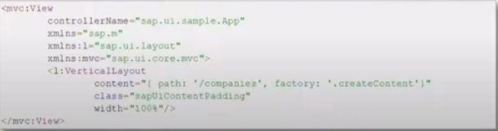

***37) What is Difference between Factory Function and Formatter?***

***Ans: --*** *A* ***factory function****allows you to create different types of controls in runtime. Let's assume that you have a list and you want to display different type of list items according to your list index for instance or maybe to some value that you have in your model. A factory function allows you to do it in the binding way.*

***Formatters****are some kind of a helper functions which receive and input and return an output. The most popular examples are date and time that you receive date in form A and return date in form B. formatter functions are defined on a property level so if you have a field in your list item which display a date you can use formatter in order to do a very simple manipulation to this date.*

***38) How to disable Web Security?***

***Ans: --*** *chrome.exe --user-data-dir="c:/temp/chromedev" --disable-web-security*

***39)* Closure *in JavaScript?***

***Ans: --*** *That means self-invoking functions.*

Ex: var add = (function () {  
    var counter = 0;  
    return function () {return counter += 1;}  
})();

*Self-invoking function only runs once. It sets the counter to zero (0), and returns a function expression. This way ‘add’ becomes a function. The "wonderful" part is that it can access the counter in the parent scope. This is called a JavaScript****closure****.*

***The benefit of self-invoking functions is that they enable us to execute code once without cluttering the global namespace (without declaring any globals).***

***40) How to use* Fragments*?***

***Ans: --***

var test1 = sap.ui.xmlfragment("mbile.myfragment",oController);

<core:Fragment fragmentName=*"nameSpace.insurance.Questionnaire"* type=*"XML"* />

***FrgmentDefinition*** *is the Element which is used for fragment creation.*

***41) How many libraries up to now you used?***

***Ans: --*** *sap.m, sap.viz, sap.ui.comp, sap.ui.suite, sap.ui.table, sap.ui.core, sap.ui.layout, sap.ui.unified, sap.ui.ux3, sap.ui.commons.*

***42) How to remove first element in an array?***

***Ans: --*** *The* ***shift()*** *method removes the first element of an array (and "shifts" all other elements to the left)*

***43) How to add first element in an array?***

***Ans: --*** *The* ***unshift()*** *method adds new elements to the beginning of an array.*

***44) How to merge two arrays?***

***Ans: --*** *The****concat()****method creates a new array by merging (concatenating) existing arrays.*

***45)* toString()** method in ***arrays?***

***Ans: --*** *The JavaScript method****toString()****converts an array to a string of (comma separated) array values.*

***46) typeOf() operator in JavaScript?***

***Ans: --***

* *The data type of* ***NaN*** *is* ***number***
* *The data type of an* ***array*** *is* ***object***
* *The data type of a* ***date*** *is* ***object***
* *The data type of* ***null*** *is* ***object***
* *The data type of an* ***undefined*** *variable is****undefined****\**
* *The data type of a* ***variable*** *that has not been assigned a value is also****undefined****\**

***47) How to remove first letter of a string in JavaScript?***

***Ans: --*** *The* ***substring()*** *method extracts the characters from a string, between two specified indices, and returns the new sub string.*

*Ex: function myFunction() {*

*var str = "Hello world!";*

*var res = str.substring(1,4);……………..(starting, ending positions)*

*document.getElementById("demo").innerHTML = res;*

*}* ***Output:*** *ell*

***48) indexOf()*** *a string in JavaScript?*

***Ans: --*** *The****indexOf()****method returns the index of (the position of) the****first****occurrence of a specified text in a string.*

***49)******lastIndexOf()*** *a string in JavaScript?*

***Ans: --*** *The****lastIndexOf()****method returns the index of the****last****occurrence of a specified text in a string.*

***50)* search() *method*** ***in JavaScript?***

***Ans: --*** *The****search()****method searches a string for a specified value and returns the position of the match.*

***51) Difference between* indexOf*() and* search() methods in *string in JavaScript?***

***Ans: --*** *The two methods,* ***indexOf()*** *and* ***search()****, are equal?*

*They accept the same arguments (parameters), and return the same value?*

*The two methods are NOT equal. These are the differences:*

* *The* ***search()*** *method cannot take a second start position argument.*
* *The* ***indexOf()*** *method cannot take powerful search values (regular expressions).*

***52)* substr() *in JavaScript?***

***Ans: --*** ***substr()****is similar to slice().*

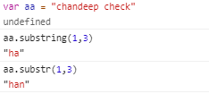

***53)******replace()****method in JavaScript?*

***Ans: --*** *The****replace()****method replaces a specified value with another value in a string.*

***54)******toUpperCase() , toLowerCase()*** *in JavaScript?*

***Ans: --***

* *A string is converted to upper case with****toUpperCase().***
* *A string is converted to lower case with****toLowerCase().***

***55)* charAt(), charCodeAt()**  ***in JavaScript?***

***Ans: --***

* *The****charAt()****method returns the character at a specified index (position) in a string.*
* *The****charCodeAt()****method returns the Unicode of the character at a specified index in a string.*

***56)* split() *in JavaScript?***

***Ans: --*** *A string can be converted to an array with the****split()****method.*

***57)* callback() *in JavaScript?***

***Ans: --*** *JavaScript statements are executed line by line. However, with effects, the next line of code can be run even though the effect is not finished. This can create errors. To prevent this, you can create a callback function. A callback function is executed after the current effect is finished.*

***Typical syntax: $(selector).hide(speed, callback);***

***58) Selectors in CSS****?*

***Ans: -- CSS*** *selectors are used to "find" (or select) HTML elements based on their element name, id, class, attribute, and more.*

***59) Types of Binding and Binding Modes?***

***Ans: --***

* **One Way*:*** *One-way binding means a binding from the model to the view; value changes in the model update all corresponding bindings and the view.*
* **Two Way*:*** *Two-way binding means a binding from the model to the view and from the view to the model; value changes in the model and in the view update all corresponding bindings and the view and model, respectively*.
* **One Time*:*** *One-time binding means from model to view once.*

|  |  |  |  |
| --- | --- | --- | --- |
| **Model** | **One-way** | **Two-way** | **One-time** |
| Resource model | -- | -- | X |
| JSON model | X | X | X |
| XML model | X | X | X |
| OData model | X | X | X |

*Default Binding Mode of Models*

|  |  |
| --- | --- |
| Model | Default binding mode |
| Resource model | One-time |
| JSON model | Two-way |
| XML model | Two-way |
| OData model | One-way |

***60) Restful API?***

***Ans: --*** *Representational state transfer API. Restful API uses http request to perform crud operations.*

***61) Promise function in JS?***

***Ans: --* Executor** *a function that is passed with the arguments resolve and reject. The executor function is executed immediately by the Promise implementations, passing resolve and reject functions (the executor is called before the Promise constructor even returns the created object). The resolve and reject functions, when called, resolve or reject the promise, respectively. The executor normally initiates some asynchronous work, and then, once that completes, either calls the resolve function to resolve the promise or else rejects it if an error occurred. If an error is thrown in the executor function, the promise is rejected. The return value of the executor is ignored.*

***Syntax:*** let promise = new Promise(function(resolve, reject) {

// executor (the producing code, "singer")

});

***Example:*** *var promise1 = new Promise(function(resolve, reject) {*

*setTimeout(function() {*

*resolve('foo');*

*}, 300);*

*});*

*promise1.then(function(value) {*

*console.log(value);*

*// expected output: "foo"*

*});*

*console.log(promise1);*

*// expected output: [object Promise]*

***62) [How to Access Elements from XML Fragment by ID?](https://stackoverflow.com/questions/39660161/how-to-access-elements-from-xml-fragment-by-id)***

***Ans: --***

var fragmentId = this.getView().createId("fr1");

var tab = sap.ui.core.Fragment.byId(fragmentId, "tab1");

***63) How to use Camera functionality in SAP UI5?***

***Ans: --*** *We have to use core HTML UI element inside content declare video tag with autopaly.*

*For camera functionality*

***navigator.mediaDevices.getUserMedia({***

***video: true***

***}).then(handleSuccess);***

**64) Formatter Declaration?**

**Ans: --**

**In** **View**

state="{ parts: [ {path: 'File>FileSize'} ], formatter: '.formatter.FirstFormatter' }"

**In Controller**

"com/Tricon/Learn/model/formatter",

formatter: formatter,

**65) What is SAP UI5?**

**Ans: --** SAP UI5 is a framework to develop responsive web application.

The word responsive doesn’t mean fast. Responsive web application is an application once you develop such an application it has capability to adopt itself to all the devices. It gives coherent experience.

These applications can be executed on different platforms, different browsers and different devices.

**Plugin:** src=”resources/sap-ui-core.js”

**66) What is Frame work?**

**Ans: --** Collection of libraries, each library includes classes, each class include methods.

**67) What is Deep Entity?**

**Ans: --** Deep insert is used to POST the nested structure of feed/collections to the back-end system.

**68) What are Custom controls?**

**Ans: --**

I will show a simple demonstration where you can **Add Properties**, **Events** and **Display a new button** that we created and use in SAPUI5 application.

**Step 1:-** Create a sample SAPUI5 project in WebIDE

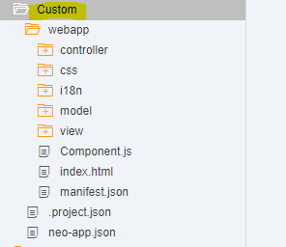

**Step 2:-** Create a folder – Custom

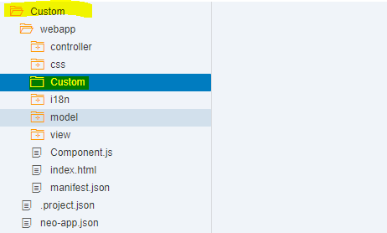

**Step 3:-** Create a js file

For demo purpose I have named it Sagar (means Ocean in Sanskrit).

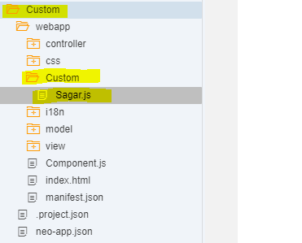

### Step 4:- Provide a control name

**com/sampleCustom/Custom/Sagar** which will be extended to **sap/ui/core/Control**

**Metadata** consists of the **properties**, **aggregations**,**associations** and **events**. For demo purpose I have provided the properties **width** and **height** and an event **hover**.

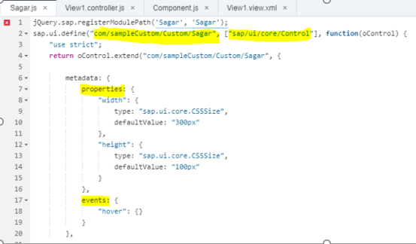

**In the renderer function you will write the**HTML**content and I have bound the**meta properties to the button**I have created.**

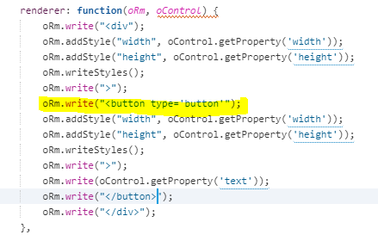

**For the demonstration of event I have created**hover**and for the**dynamic passing**values I have created a**property text**.**

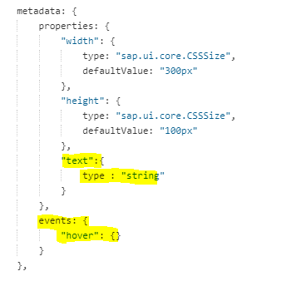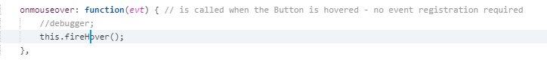

**To trigger the events make sure on render you add an extra line of code**

oRm.writeControlData(oControl);

**Step 5:-** Use the custom control and define function in controller & view

Take note of xmlns:Sagar=”com.sampleCustom.Custom” and hover function “fnHover”.

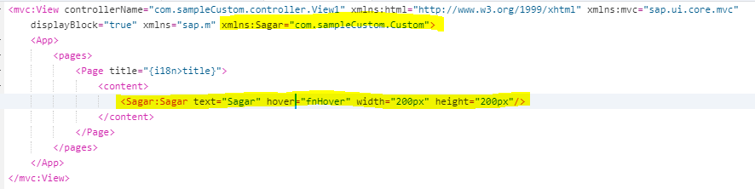

Define the fnHover function as below.

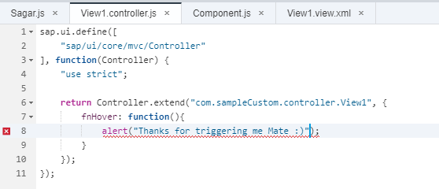

### Output:-

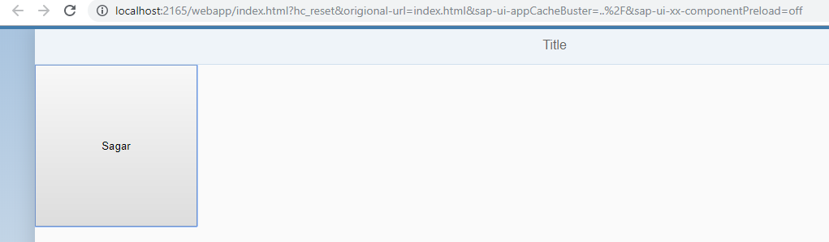

Now keep move cursor on that new control, look the event hover is triggered

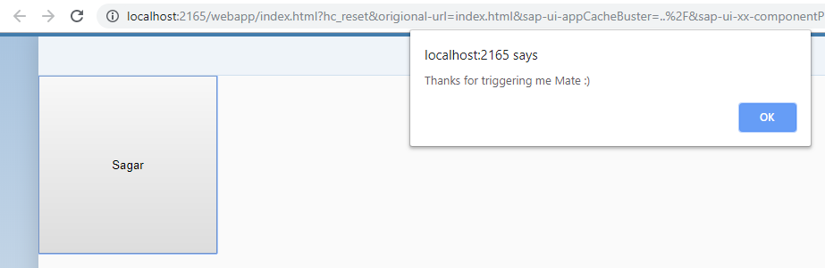

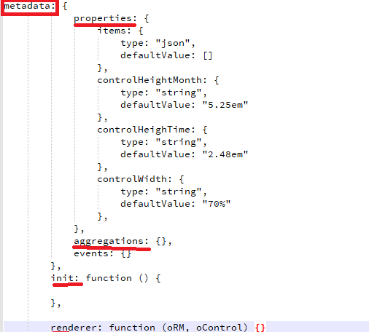

**69) Cross App Navigation?**

**Ans: --** In order to achieve cross-app navigation in SAP Fiori we define intents in the SAP UI5 application. Intents acts as a target and is mapped with the actual URL at run time. Intents comprises of a semantic object and action to be performed.

sap.ushell.Container.getServiceAsync("CrossApplicationNavigation").then( function (oService) {

var sHref = oService.hrefForExternal({

target : {

semanticObject : "Product",

action : "display" },

params : {

"ProductID" : "102343333"

}

}) || "";

// do something with sHref

});

**70) How to load local json file?**

**Ans:--**

var sPath = jQuery.sap.getModulePath("namespace", "/path/to/file.json");

      // initialize the model with the JSON file

      var oModel = new JSONModel(sPath);

      // set the model to the view

      this.getView().setModel(oModel, "jsonFile");

**71) Sequence of Hook Methods?**

**Ans: --**

1. **onInit**
2. **onBeforeRendering**
3. **onAfterRendering**
4. **onExit**

onExit () -> This method gets invoked when object of your constructor is destroyed: so all the cleanup code should be written in this method. It is the Destructor of the class.

OnBeforeRendering () -> this method gets called before the UI is displayed to the USER: i.e UI modification before it is displayed to the USER: eq. Auth checks, UI modifications before the UI is rendered. But: effects like jQuery will not be displayed since UI is yet to be displayed.

onAfterRendering () -> this method is triggered once the UI is loaded/ so all your “jQuery” effects and CSS can be applied in this method.

Ex:

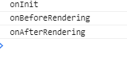

**72) Purpose of onExit?**

**Ans:--**

Usually you just implement Components

destroy: function() {

if (this.oRouteHandler) {

this.oRouteHandler.destroy();

}

sap.ui.core.UIComponent.prototype.destroy.apply(this, arguments);

},

And that takes care of destroying event handlers on the components event bus and associated UI elements.

When you create a fragment, make sure you call addDependent of the view where you use it so fragments will get destroyed too.

**73) Use of “Strict” key word in JS?**

**Ans: --**

Strict mode is declared by adding "use strict"; to the beginning of a script or a function.

Declared at the beginning of a script, it has global scope (all code in the script will execute in strict mode):

The keyword “use strict” with throw a syntax error if the dependency is defined in the scaffolding and not used anywhere in the controller logic.

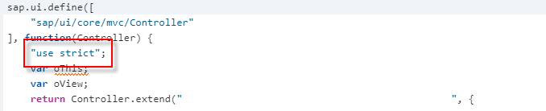

Ex:-

"use strict";  
x = 3.14;       // This will cause an error because x is not declared

myFunction();  
  
function myFunction() {  
  y = 3.14;   // This will also cause an error because y is not declared  
}

**74) Resource Bundle?**

**Ans: --** A resource model is instantiated with a bundleName or a bundleURL. The bundle name is the name of the resource bundle and equals a SAPUI5 module name within the define/require concept. The bundle URL points to a resource bundle. If you use the bundle name, the file must have the .properties suffix. If you do not specify a locale, the system uses the login language:

var oModel = new sap.ui.model.resource.ResourceModel({bundleName:"myBundle",locale:"en"});

var myBundle = oModel.getResourceBundle();

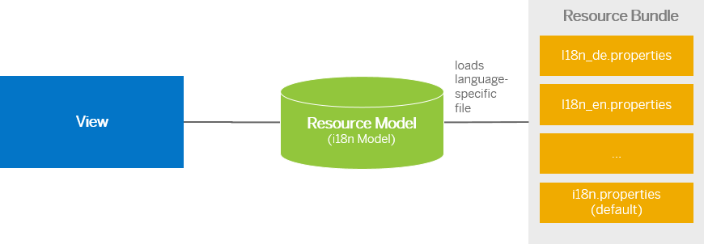

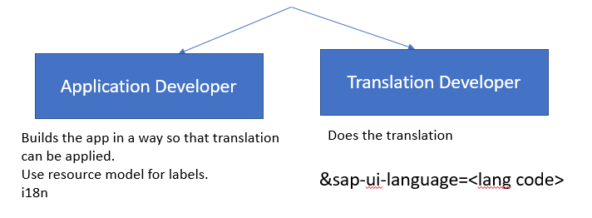

**75) Difference between json and OData model?**

**Ans: --** OData model is a model based on an OData Service which a REST based model.

The OData Model is a server-side model, so the whole dataset is only available on the server, the client only knows the currently visible rows and fields.

When you bind a control to an OData model, it comes with many features out of the box such and filtering capability, sorting, pagination etc.

On the other hand JSON model is client side model based on JSON data to be used for small set of data.

**76) Reason for using xml view?**

**Ans: --** the reason I use XML views is because this is the standard approach of the Fiori apps by SAP. It creates a situation where developers only have 1 approach. Also to me they are easier readable.

1. To protect MVC (Model-View-Controller) guidelines: If a developer uses JavaScript views, then there is chance of putting processing code in the view itself, which violates the MVC principle.
2. As XML is not a programming language, there is no way you can put processing logic inside XML views. So, in that case, you will always use controller to put your processing logic following MVC architecture.
3. Parsing of XML in devices is faster than JavaScript.

**77) When Do You Use Element Binding?**

**Ans: --** Element binding allows you to bind elements to a specific object in the model data, which will create a binding context and allow relative binding within the control and all of its children. When you want bindings of child controls to resolve their paths relative to the binding of the parent.

Ex: var oInput = this.byId("companyInput")

oInput.bindElement("/company");

oInput.bindProperty("value", "name");

Typically – in a Master-Detail Functionality in SAP, whenever, user clicks on a Master record in the view, corresponding detail data is displayed in the Detail View. So, in order to get the selected data into the corresponding UI.

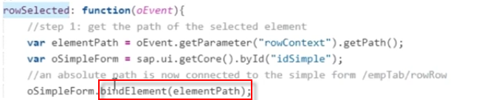

What is Relative Path?

A Relative path is the child node to the existing node.

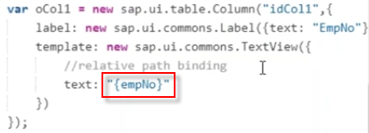

What is Absolute Path?

Absolute path is direct children of root element

https://sapyard.com/wp-content/uploads/2020/01/image066.png?x55810

**78) What is Router Class?**

**Ans: --**

**Scenario1:**



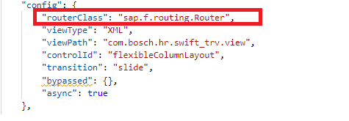

**Scenario2:**



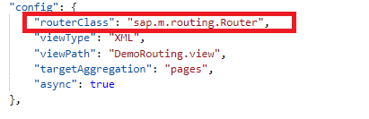

**79) How to get the path of the element?**

**Ans:--**

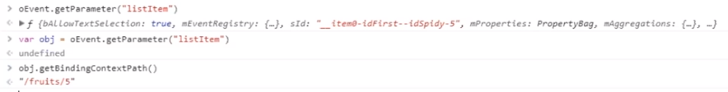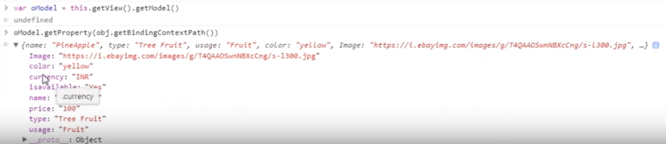

**80) Sorting and Grouping?**

**Ans:--**

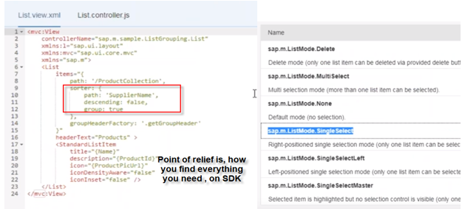

**81)** **Creating a Filter on the List Items?**

**Ans:--**

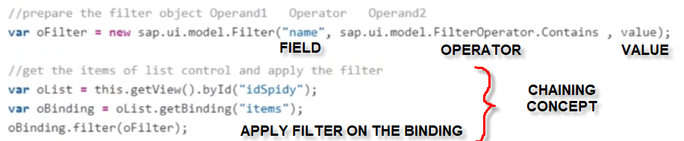

To apply multiple filters:

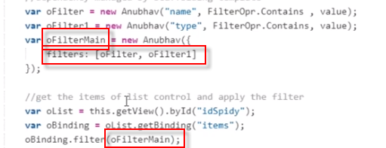

To note that, the Filter Operation is by default: “OR” operation: to make it and you need to specify as following:

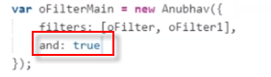

**82) What is component.js?**

**Ans: --** Component.JS wraps the functionality of entire application. It also provides an “entry point” for our Fiori App.

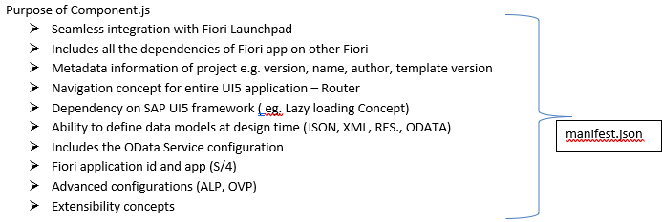

**83) Git Vs GitHub?**

**Ans: -- Git** is a version control system that lets you manage and keep track of your source code history. **GitHub** is a cloud-based hosting service that lets you manage Git repositories. If you have open-source projects that use Git, then GitHub is designed to help you better manage them.

**84) What do you mean by git Commit?**

**Ans: --** The "commit" command is used to save your changes to the local repository.

**85) What do you mean by git push?**

## Ans: -- The git “push” command is used to transfer or push the commit, which is made on a local branch in your computer to a remote repository like GitHub.

**86) Important T-codes?**

**Ans: --**

|  |  |  |
| --- | --- | --- |
| **SrNo** | **T-code** | **Description** |
| 1 | SICF  (Path: /sap/bc/ui5_ui5/sap/) | UI5 Application Path |
| 2 | SICF  (Path: /sap/opu/odata/sap/) | Odata Service Path |
| 3 | /n/iwfnd/maint_service | Odata Service Registration |
| 4 | /n/UI2/SEMOBJ_SAP | Semantic objects by SAP |
| 5 | /n/iwfnd/error_log | Error Log |
| 6 | LPD_CUST | Launchpad Role |
| 7 | PFCG | PFCG Role |
| 8 | /UI5/THEME_DESIGNER | create, edit, copy, delete, or rebuild/upgrade a theme |
| 9 | /UI2/FLP | Launchpad for Business Users |
| 10 | /UI2/FLPD_CUST | Client Specific Launchpad configuration |

***87) What is SAP Fiori?***

**Ans: -- FIORI** *is a set of Design Principles and / or Guidelines. These principles and guidelines derive the User Experience for designing an app. It defines dos and don’ts of a user interaction. SAP Fiori provides a role-based experience across all lines of business, tasks, and devices.*

*The difference is that Fiori is a design concept, and SAPUI5 is a library framework. You can still build custom UI5 Apps that do not adhere to the SAP Fiori design guidelines, but they are called custom UI5 Apps.*

***88) What are the SAP Fiori design guide lines?***

**Ans:--**

* ***Role-Based****− SAP has decomposed various SAP transactions and changed them into beautiful user interactive applications that show only most relevant information to the users.*
* ***Responsiveness****− When SAP Fiori is combined with the power of SAP HANA, it provides an unmatched application response and query executions time.*
* ***Simple****− To make SAP Fiori simple to match the user demand, SAP has designed it as a 1-1-3 scenario. This means 1 user, 1 use case and 3 screens.*
* ***Seamless Experience****− SAP has provided all the Fiori apps based on the same language and it does not matter on the deployment and platform.*
* ***Delightful****− SAP Fiori was designed to work with ECC 6.0 to make it easy for the users and to deploy on the existing SAP system.*
* ***Adaptive*** *– Adapts to multiple use cases and devices.*

***89) What is SAP Fiori Launch Pad?***

***Ans:--***

* SAP Fiori Launchpad is a shell that hosts SAP Fiori apps, and provides the apps with services such as navigation, personalization, embedded support, and application configuration.
* SAP Fiori Launchpad is the entry point to SAP Fiori apps on mobile and desktop devices.

**90) What are the types of SAP Fiori Application?**

**Ans: --**

* **Transactional apps: -** Task based Access, Access to tasks like change, create or entire processes with guided navigation.
* **Fact sheets: -** Search and Explore, View on essential information about an object and contextual navigation between related objects.
* **Analytical apps: -** Insight to action, Visual overview over complex topic for monitoring or tracking purposes.

**91) What are the various scenarios which are covered by SAP Fiori Elements Floor Plans?**

**Ans: --** SAP Fiori Elements provides you five different templates. These templates are actually again made looking at the most commonly used business cases.

* [Analytical list page](https://experience.sap.com/fiori-design-web/analytical-list-page/)
* List report
* Object page
* Overview page
* [Worklist](https://experience.sap.com/fiori-design-web/work-list/)

**92) What are tiles in Fiori Launchpad?**

**Ans: --**

* **Static** − A standard tile that displays static content. You basically configure a title, subtitle, and an icon.
* **Dynamic**− A tile that displays data that is updated at regular intervals. The data is retrieved from a backend system using OData services.
* **News Tile** − Displays a news feed alternating between messages according to how you configure the tile. Only used for the News app type.
* **KPI Tile** −Displays Key Performance Indicators (KPIs) on a tile in real time.

Example: Used for KPI tiles created in SAP Smart Business.

**93) What is Fiori Elements?**

**Ans: --** Fiori elements is a framework to build fiori apps. Using Fiori elements you can actually build apps based on oData and annotation without any JavaScript coding.

We use template based approach which ensures that there is a common look and feel and UI behavior across all apps which are built using Fiori Elements.

**94) Fiori Roles and Authorizations?**

**Ans:--**

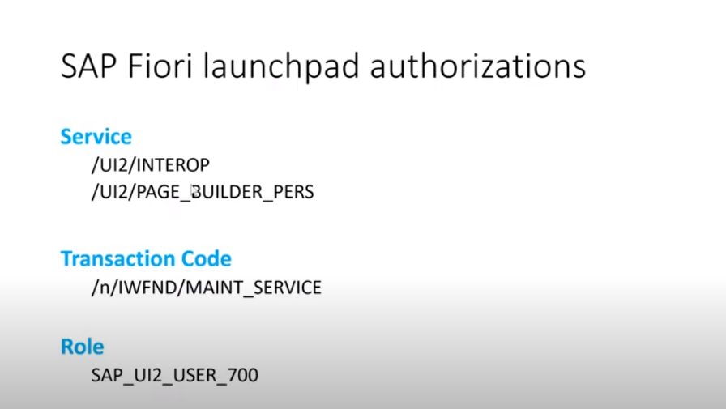

**95) What is Catalog, Group, and Role in SAP Fiori?**

**Ans: --**

**Catalog:** A catalog is a set of apps you want to make available for one role. Depending on the role and the catalogs assigned to the role, users can browse through the catalogs and choose the apps that they want to display on the entry page of the SAP Fiori Launchpad.

**Group:** A group is a subset of apps from one or more catalogs. Which tiles are displayed on a user’s entry page depends on the groups assigned to the user’s role. In addition, the user can personalize the entry page by adding or removing apps to pre-delivered groups or self-defined groups.

**Roles (PFCG):** Provides access to the assigned groups and catalogs.

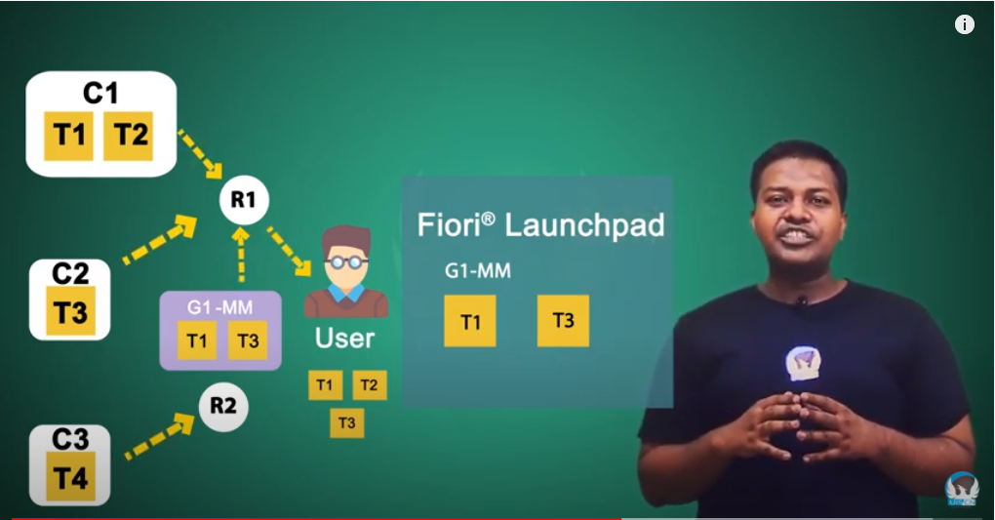

**96) What is the difference between SAP Fiori, SAP Fiori Apps and SAP Fiori Elements?**

**Ans: --** SAP Fiori is actually user-experience, a new user-experience for sap software’s. It’s a set of guidelines which actually describes the look and feel of UI and behaviors.

SAP Fiori APP is basically an app which actually adhere to this user-experience guide lines.

And Fiori elements basically is a framework which can be used to generate these apps using oData and annotations.

**97) What is the difference between developing an SAP Fiori elements application and hand coded UI5 App?**

**Ans: --** Fiori elements provides you standard templates, which are made based on the most commonly used business cases. If your use case really fit into this one of this particular template, then

We should be using Fiori elements to build the app.

Whereas SAP UI5 is something which provides you a set of controls, layouts, style sheets adhering to SAP Fiori guidelines. Without Fiori elements you need to have front-end development knowledge to put all these things together to make your fiori app.

**98) The apps are developed using fiori elements can they be used alongside SAP UI5 Apps?**

**Ans: --** Fiori elements uses the ui5 framework to generate the apps. All the apps which are actually created using Fiori Elements.

**99) Authorization and Authentication?**

**Ans:-**

**Authentication:** Giving access to enter into the system. Entry point to the system.

**Authorization:** Once user enter inside the system, what tasks/activities then can perform?

**100) what is a repository in a Git?**

**Ans: -** Repositories in GIT contain a collection of files of various different versions of a Project. These files are imported from the repository into the local server of the user for further updating and modifications in the content of the file.

**101) hub deployment** vs **embedded deployment?**

**Ans: - hub deployment** means the front end system (UI layer) and back end system (business data layer) are separate systems whereas **embedded deployment** means that both front end and back end systems are a single system.

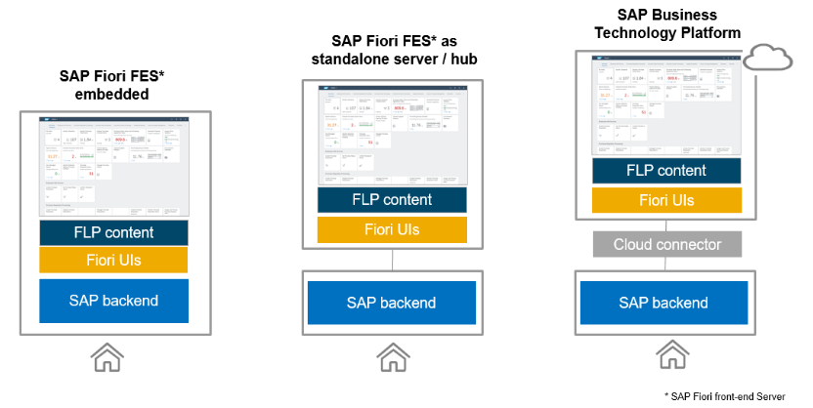

**102) How to hide columns in Smart table?**

**Ans: -** By using **“ignoredFields”** we can hide column fields in smart table.

Comma-separated value of fields that must be ignored in the OData metadata by the SmartTable control.

**103) Deep Copy in JS**?

**Ans: -** A deep copy means that all of the values of the new variable are copied and disconnected from the original variable.

**104) Spread operator?**

**Ans: -** This operator is just great, because it is so short and simple. It ‘spreads’ out all of the values into a new object. You can use it as follows:

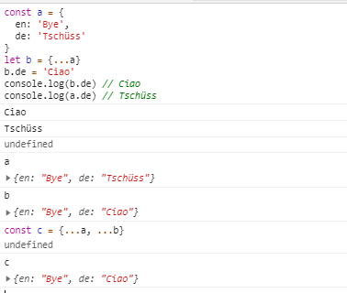

**105) Call, Bind, and Apply in Js?**

**Ans: -**

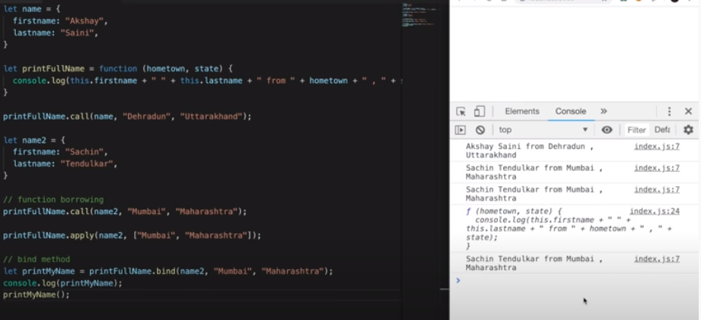

**SAP Fiori Launchpad Configuration Steps**

1. Deploy your UI5/Fiori application and take the UI Path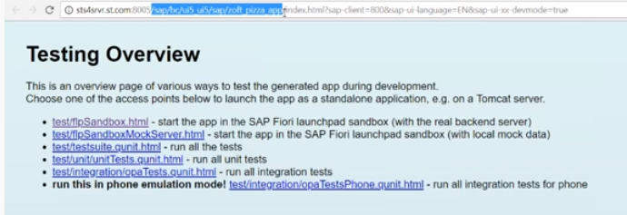
2. Check the Path in T-code *“****SICF”*** and execute it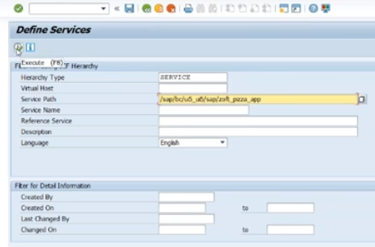
3. If our app is exists then we can see blow screen. 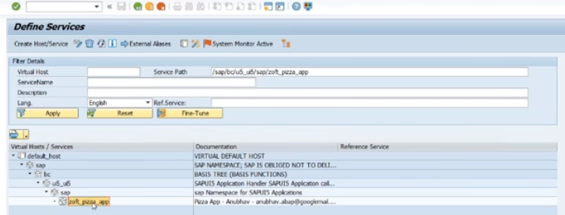
4. We need to make sure our app is up and running.
5. Use t-code “**/n/UI2/SEMOBJ”** to create semantic object. 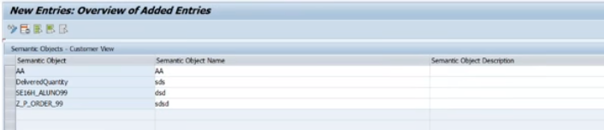
6. Use t-code “**/UI2/FLPD_CONF”** to get fiori Launchpad designer use below url. *“*[*http://stfiorisrvr.st.com:800/sap/bc/ui5_ui5/sap/arsrvc_upb_ad/main.html*](http://stfiorisrvr.st.com:800/sap/bc/ui5_ui5/sap/arsrvc_upb_ad/main.html)*”*
7. Create Business catalog. Click on Plus Icon and enter catalog title and id. 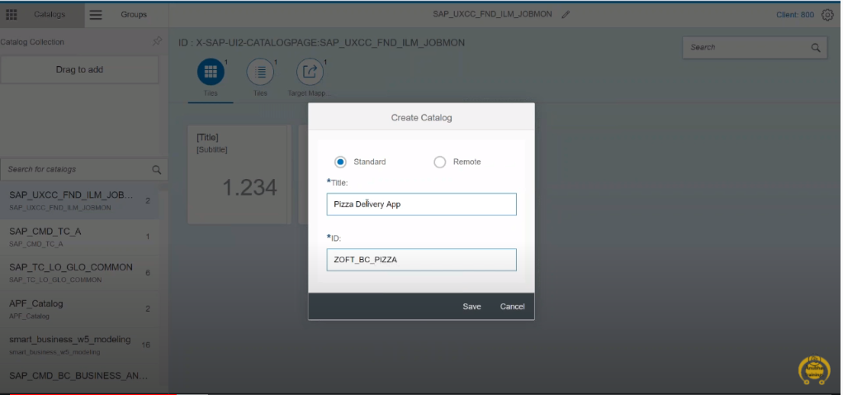
8. Once it got created then we can see below screen. 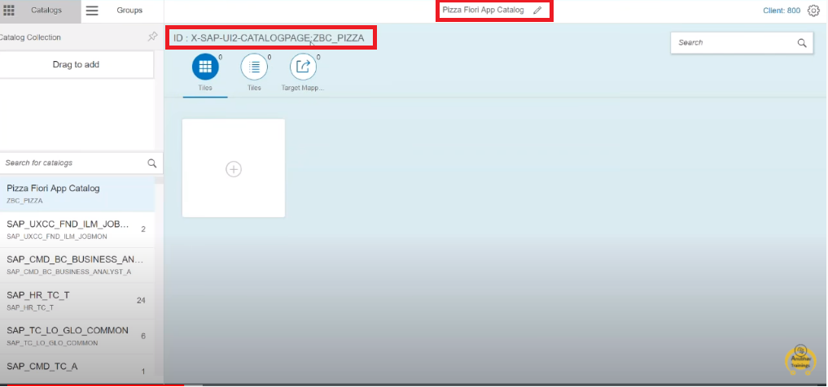
9. Then we have to create tile. Click on the tile then we have to select which type of tile is required. 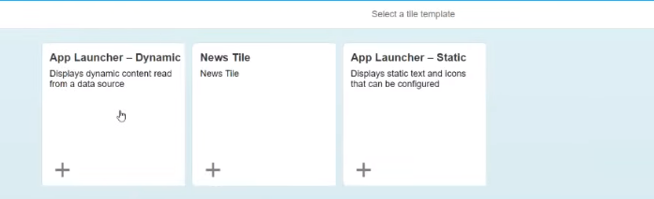
10. Then it will ask you to provide necessary details. And remember your “**Semantic object and action”** it will require later on.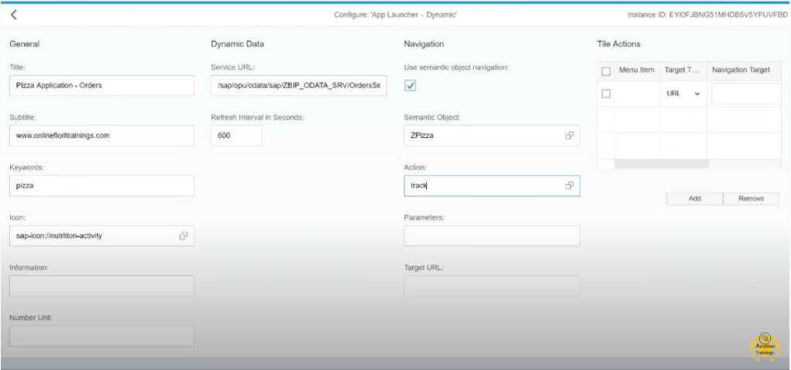
11. Save tile information then we can see below screen. 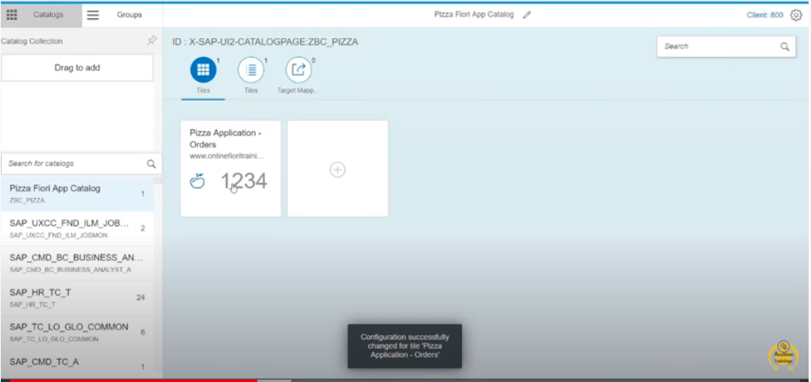
12. Then go to “**Target Mapping**”. And click on target mapping button on footer. It will ask necessary details like “**semantic object, action, application type, Title, URL, ID**”. Here ID is a reference of application “**namespcae”**.
13. 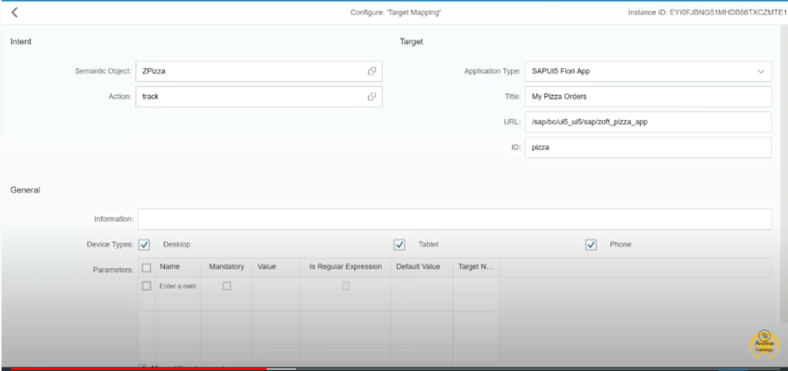
14. Once we create target mapping then we can see below screen.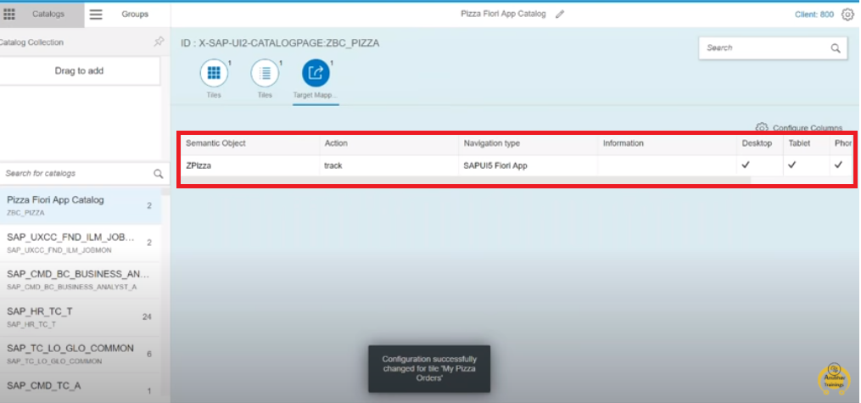
15. Then we have to create group under this tile. 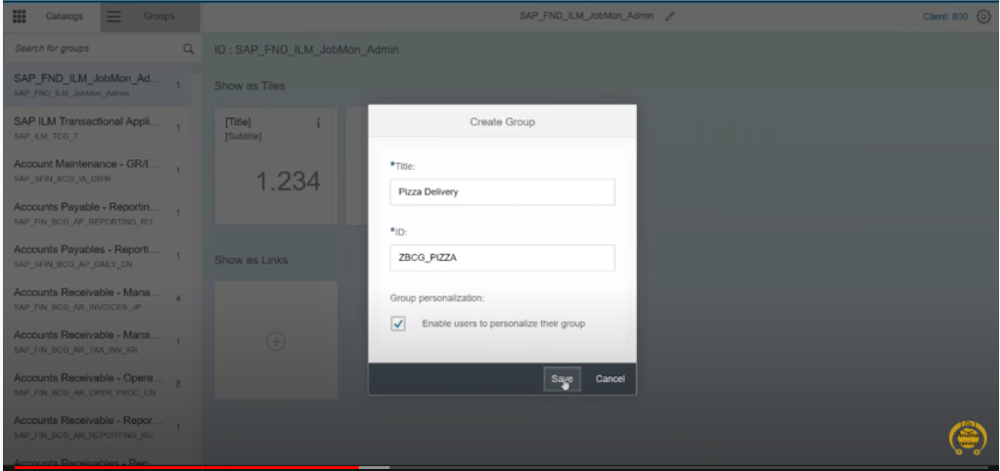

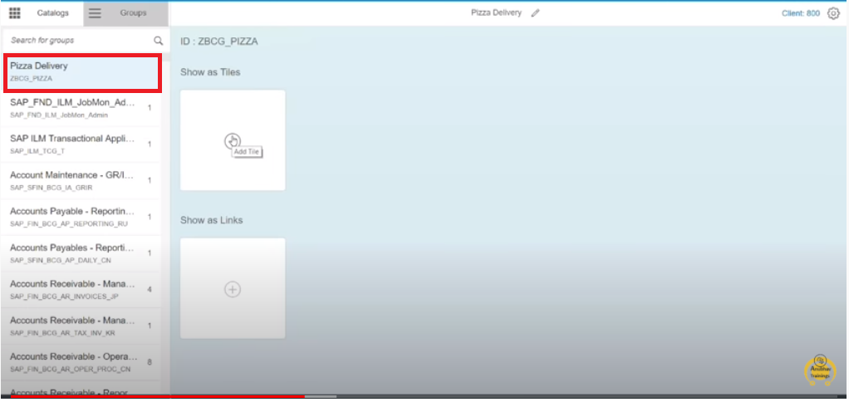

1. Then add catalog to the group. Click on the plus icon then we have to select the catalog from list of catalogs. We need to click on plus icon then it will add catalog to the group.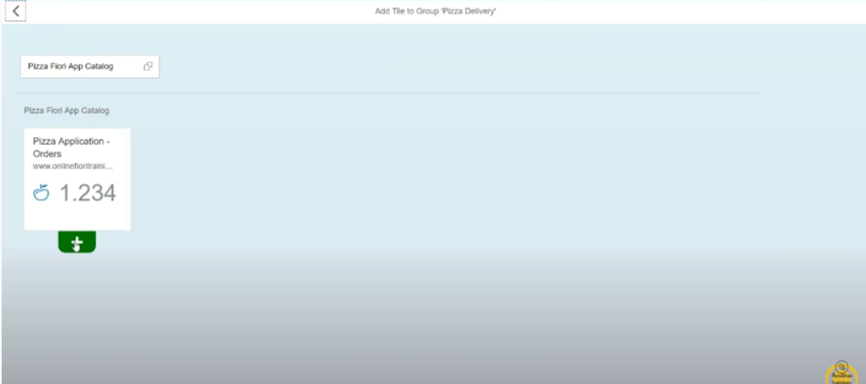 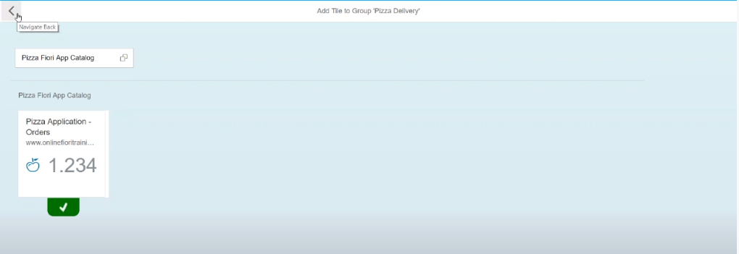
2. Once it’s gets added then we can see the catalog in group.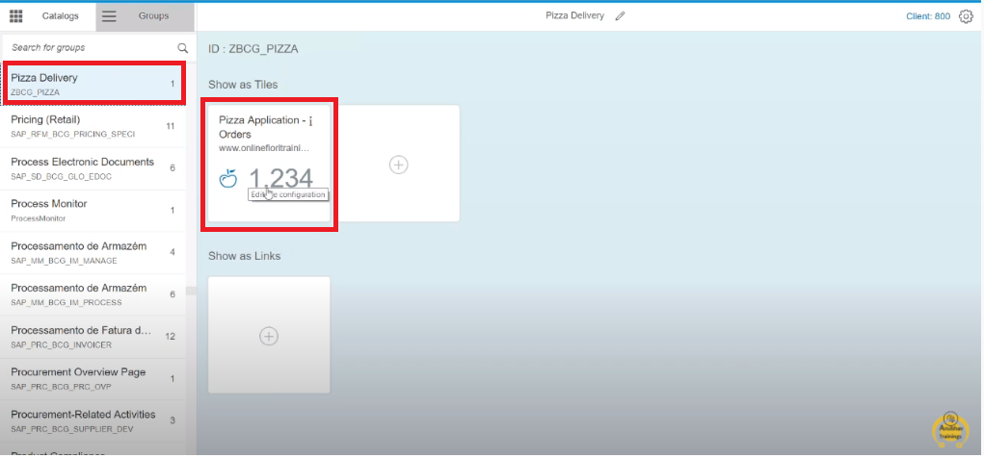
3. We have to define role for catalog, group, and OData service. Use “**PFCG”** t-code to create role. And click on “**single role**” button.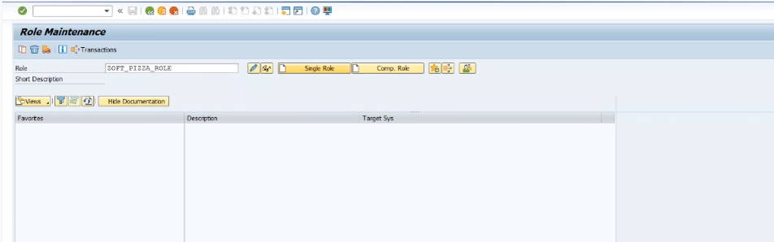
4. Go to menu inject your catalog and group. 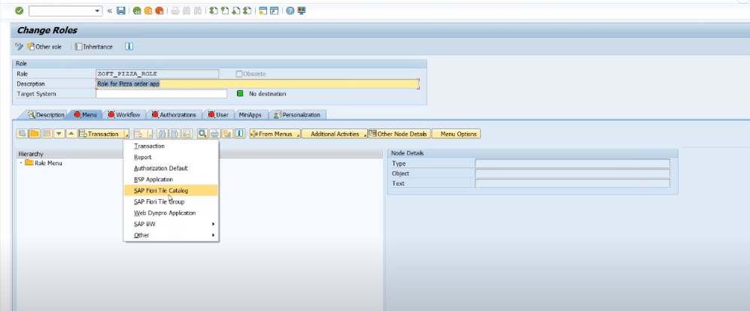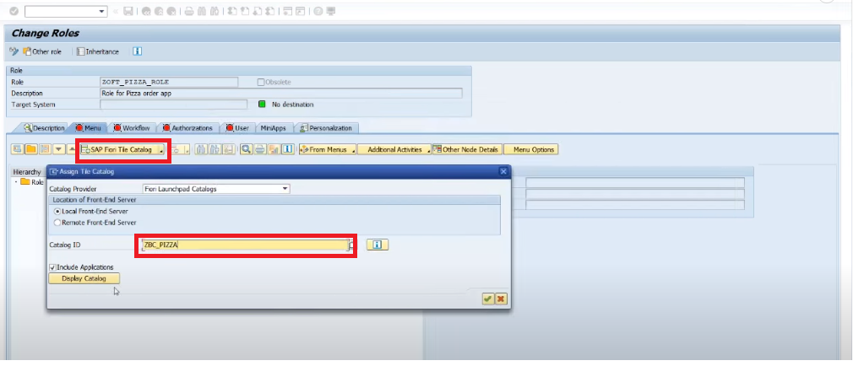 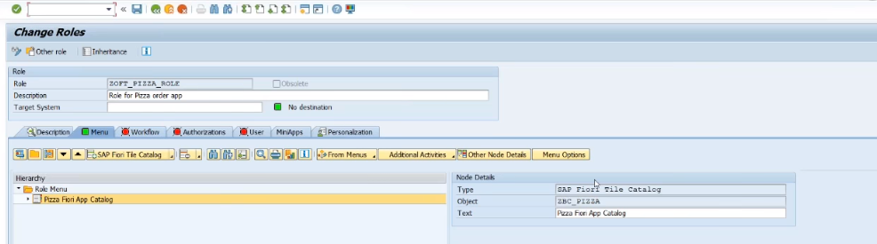 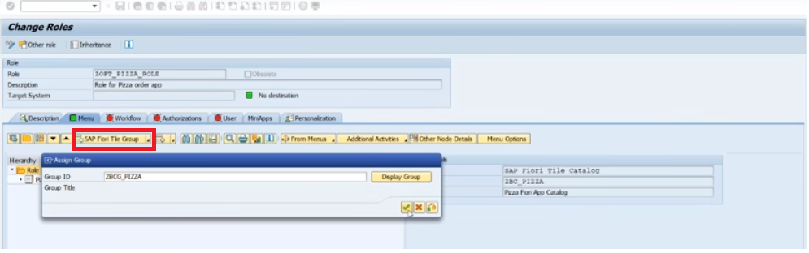 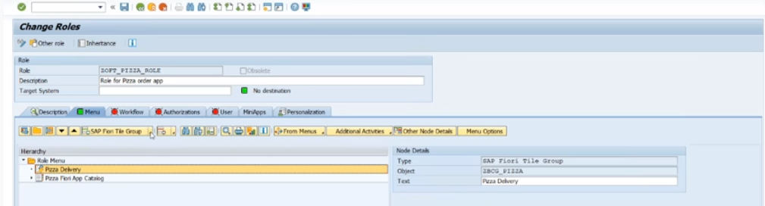
5. Add Users to the Role 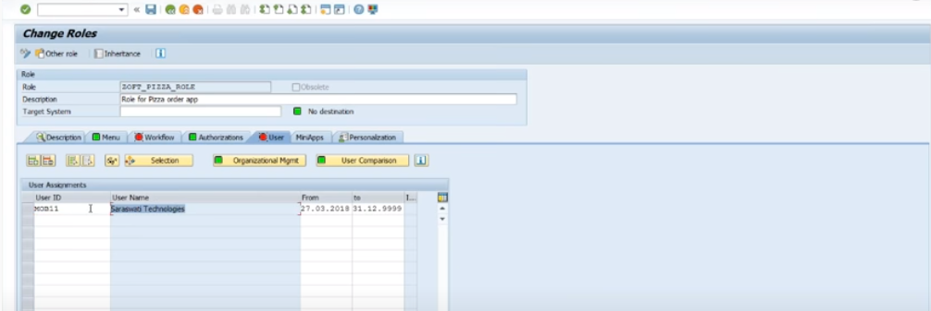
6. Use **“/UI2/FLP**” Login with sap business user then we can see our application in fiori launchpad. 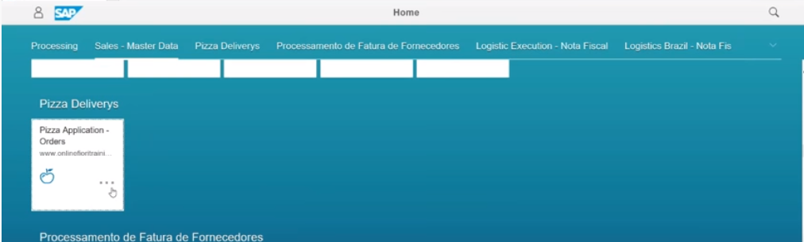

**Fiori App Extension**

**Step1:** Right click on Workspace ->New->Extension Project

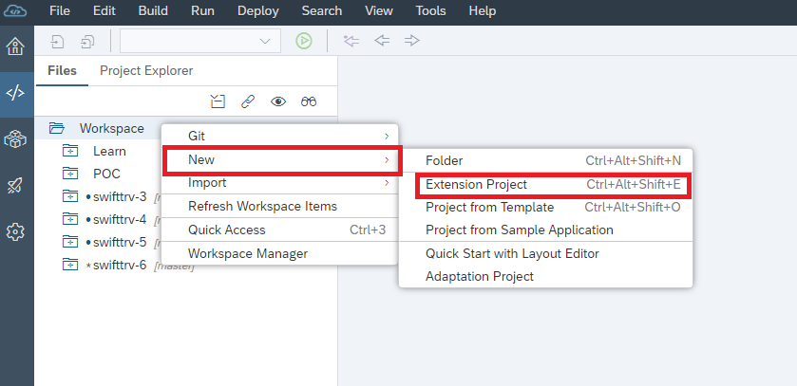

**Step2:** Expand dropdown and select SAP ABAP Repository and press Next Button.

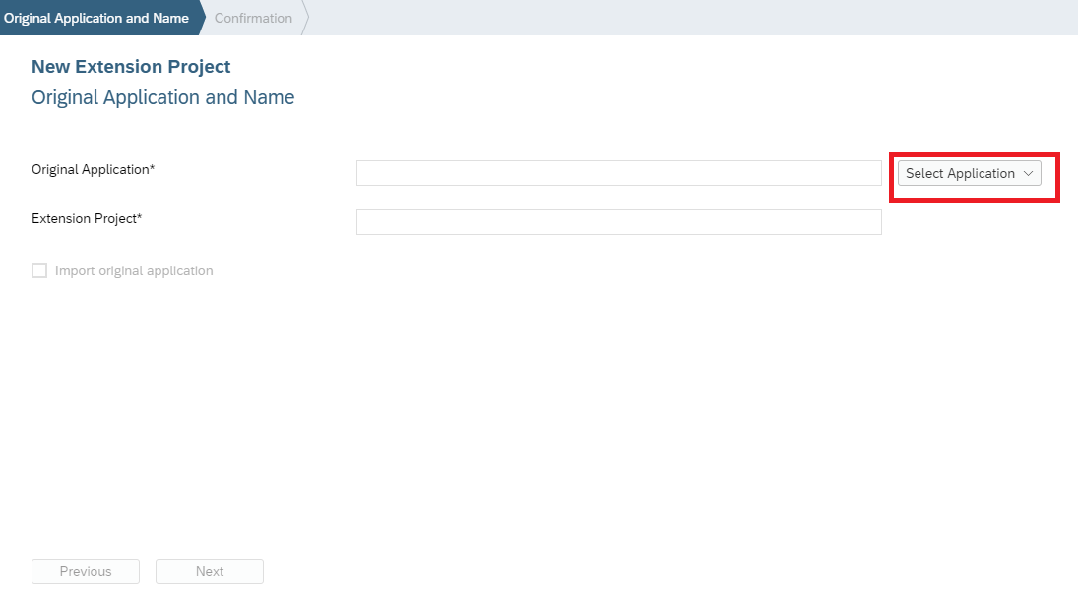

**Step3:** select your abap repository system and select application

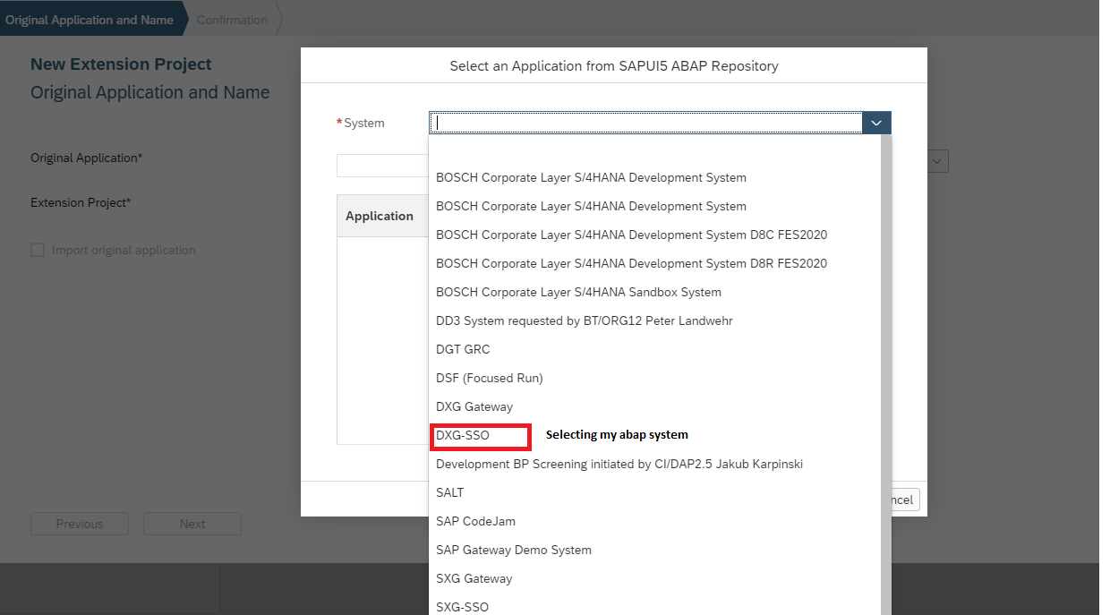

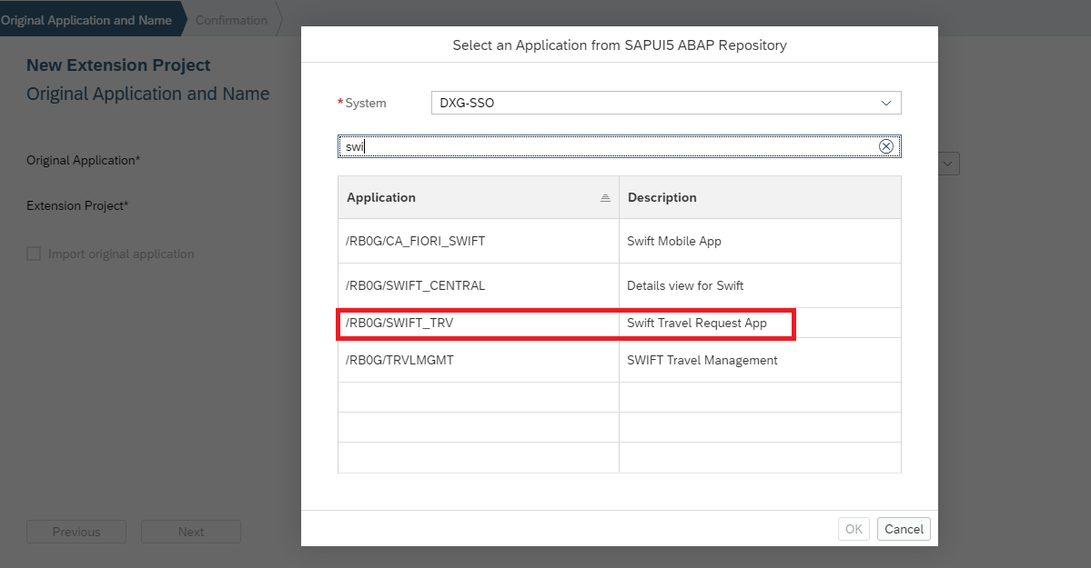

**Step4:** Press Ok Button then we can see our application and check the extension points in fiori apps library (if it is a standard fiori app)

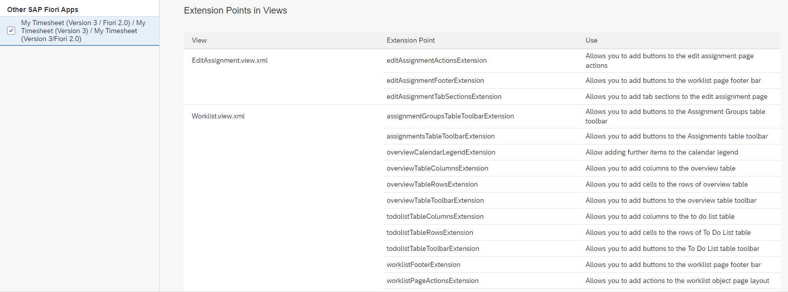

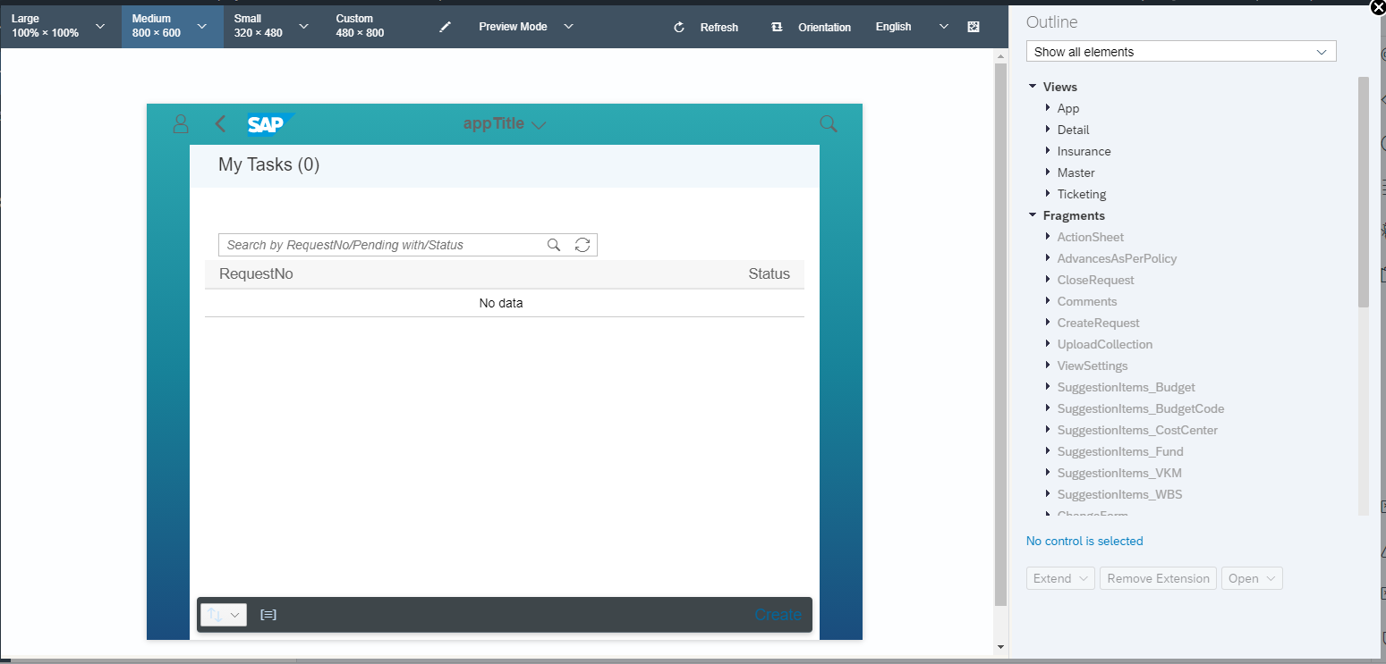

**Step5:** and right hand side we can see all UI elements, project folder.

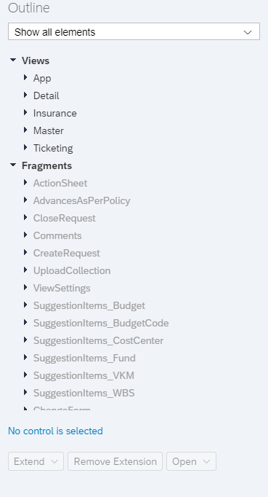

**Step 6:** Select view and Press expand button to see options.

**Expand Dropdown contains:**

1. Replace with empty view

2. Replace with copy of original view

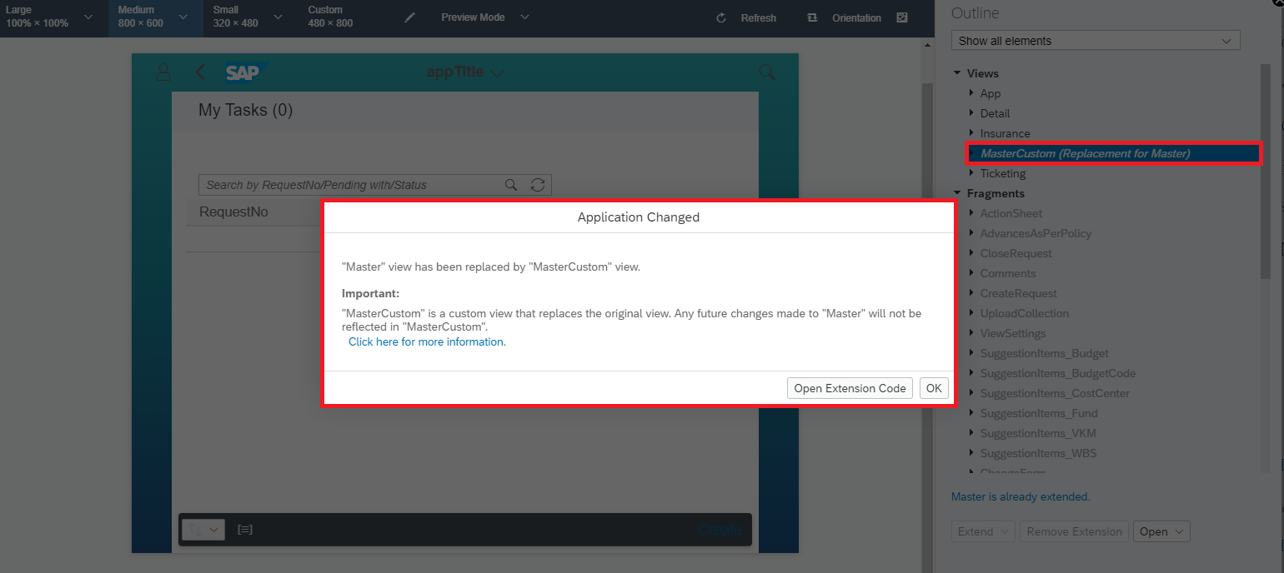

**Step7:** Press Open extension Code.

**Step8:** Project structure will be changed. Now you can able to modify MasterCustom View.

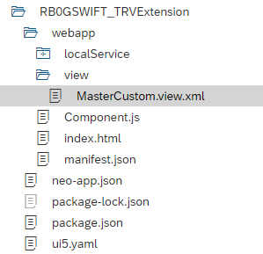

SAP UI5 Queries

What is AMD?

How to use spacebar key for button event?

1. What is a conflict in Git and how it can be resolved?
2. What is the difference between Git Pull and Git Fetch?
3. What is the difference between Git Remote and Git Clone?
4. What is the difference between Rebasing and Merge in Git?
5. What are Jenkins and how it can be integrated with Git?
6. What is a Version Control System and what are its benefits?
7. Difference between smart table and responsive table?
8. Independent custom control?
9. Hot fixes, dev fixes?
10. Release process?

